KWAME NKRUMAH UNIVERSITY OF SCIENCE AND TECHNOLOGY

COLLEGE OF ENGINEERING

DEPARTMENT OF MECHANICAL AND CHEMICAL ENGINEERING

ME 396 MECHANICAL ENGINEERING LABORATORY IV.

TRIFILAR SUSPENSION



LECTURER: Y.A.K. FIAGBE

GROUP: A

DATE: 16th APRIL, 2019.

**GROUP MEMBERS**

|  |  |
| --- | --- |
| **NAMES** | **INDEX NUMBERS** |
| Atomboh, Vincent Essuman | 5971016 |
| Nyamekye, Joel Kwaku | 5978816 |
| Krampah, Emmanuel | 5976816 |
| Koranteng, Gareth Yadah | 2289414 |
| Kotei, Amon Shane Nii |  |
| Ansah, Emmanuel Abban |  |
| Amoateng-Mensah, David | 5968816 |
| Tettey, Attoh Derrick | 5982816 |
| Otchere, Shadrack Appiah | 5980816 |
| Boye, Samuel | 5972816 |
| Eshun, Emmanuel | 5974716 |
| Afful, Joseph Kabenla Animnyam | 5967216 |

**OBJECTIVE**

To determine the moment of inertia of a connecting rod using a trifilar suspension.

**APPARATUS**

Connecting rod, cord, stop-watch, support frame, trifilar suspension table, scale

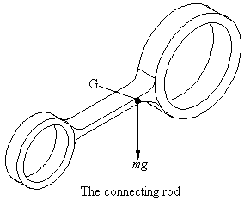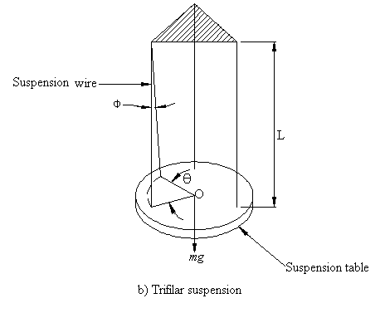

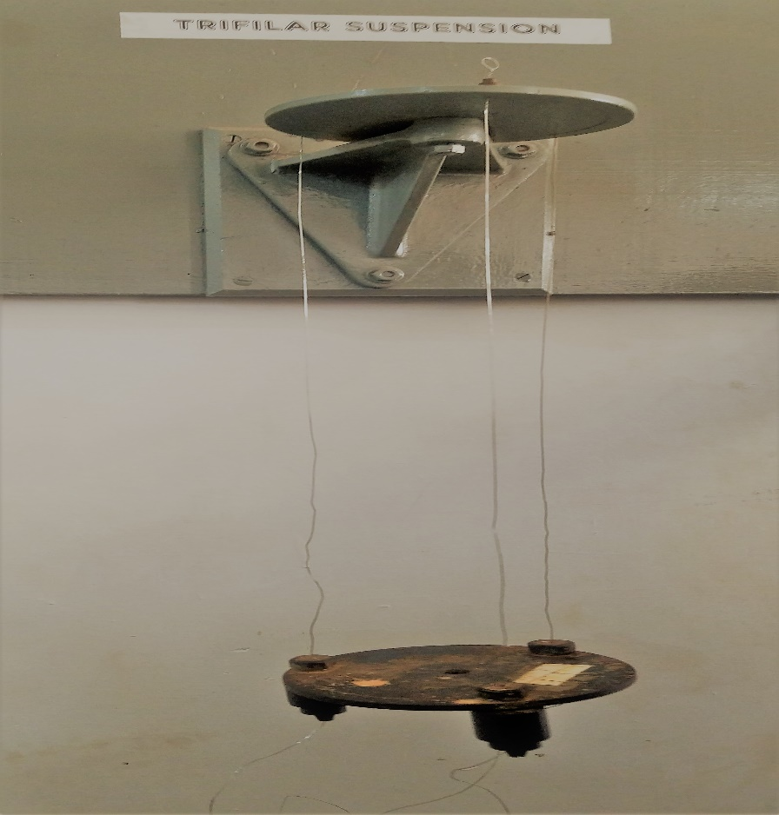

Experimental setup for a trifilar suspension

**THEORY**

Let,

*Io* = moment of inertia

*G* = center of mass of connecting rod

*L* = length of wire

 = Time period

*f* = frequency

*k* = radius of gyration

 = tension in wire

*w* = angular velocity

α = angular acceleration

*r* = radius of suspension table

=mass of connecting rod

 = mass of suspension table

*a* = distance of left wire from G

*b* = distance of right wire from G

For a trifilar suspension,



Tension in each wire = 

Component perpendicular to r =

Total restoring couple =

But 

Where is the angular acceleration.







**PROCEDURE**

1. Determine the mass, moment of inertia, and the radius of gyration of the suspension table.
2. Place the connecting rod on the table with its center of mass coinciding with that of the table.
3. Set the combination swinging about its center of mass with the wire at a certain length, ensuring the center of mass is not so much disturbed.
4. Record the time taken for 20 oscillations.
5. Repeat procedures 3 and 4, all the while, changing the length of the wire after each recording.

**RESULTS**

|  |  |  |  |
| --- | --- | --- | --- |
|  | **TABLE AND CONNECTING ROD** | | |
| **Length** | **Time** | **Period** | **Period 2** |
| **(m)** | **(s)** | **(s)** | **(s) 2** |
| 0.87 | 35.80 | 1.7900 | 3.2041 |
| 0.772 | 33.87 | 1.6935 | 2.8679 |
| 0.703 | 31.44 | 1.5720 | 2.4712 |
| 0.654 | 30.20 | 1.5100 | 2.2801 |
| 0.507 | 27.36 | 1.3680 | 1.8714 |

**DATA ANALYSIS**

**=0.065 m**

**=0.9 kg**

** =+ = 2.9kg.**

**=0.125 m**

** = 2 kg**

**r = 0.0635 m**

From (12),

where grad is the gradient of against L and r, the radius of the radius.

For moment of inertia without the rod on the table,,

g = 9.81

grad = 3.4309

m= = 2 kg



= 0.0072.

For moment of inertia with the rod on the table, ,

grad = 3.9775

m=+ = 2.9kg.



=0.01211 .



= (0.01211 – 0.0072).

= 0.00491.

Hence, the moment of the connecting rod, is 0.00491.

**CONCLUSION**

The trifilar suspension experiment, just as the bifilar suspension experiment, is also used to determine the moment of inertia of a connecting rod. Both the bifilar and trifilar suspensions, serve as a check on the other, in that, results obtained from one should be the same as the other. However, the difference(s) can be attributed to the sources of errors listed below.

**SOURCES OF ERRORS**

1. Reduction of the disturbance of the centre of mass was not 100%.
2. Errors in reading the length and mass.
3. Centre of mass of the rod not coinciding exactly with that of the table.
4. Possible non-uniformity in levelling the suspension table.

**PRECAUTIONS**

1. Reduce centre of mass as much as possible during swinging.
2. Ensure that the angular displacement is as small as possible.
3. The number of swings is chosen such that the swings do not die out.